**CS5551**

**Spring 2015**

**Advanced Software Engineering**

**Project Increment-I (PG-9)**

**Project Title: Virtual Learning**

**Submitted By:** Manisha Reddy Kattukuri (Class ID: 27)

Bala Sai Teja Gaddam (Class ID: 15)

Tejaswini Nalamotu (Class ID: 35)

Teja Mosali (Class ID: 34)

**Introduction:**

Education plays a vital role in everyone’s life. It helps them to progress and improve as individuals. Exam is a way to test their knowledge and learning capacity. Almost all the tests are organized online these days. Virtual learning is an application which provides them to overcome with all the issues related to the exam. It helps them in self analyzing their performance provides with best materials and proficient tutors who can help them in improving their leaning process, they get to manage their time as they practice and improve their performance.

1. **Usage of Existing Services:**

We have used Visual Studio as our IDE to develop our application. The application uses ASP.NET web forms applications template which provides verity of functionalities. We have designed a master page which provides a backdrop to all the pages. We have used Cascaded Style Sheets to provide styling to the master page. The rest of the web pages inherit the master page and are completely based on the default master for look and feel.

1. **Detail Design of Services:**
2. **User Stories:**

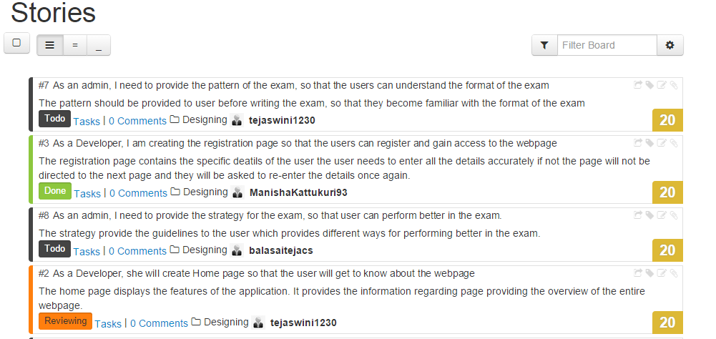

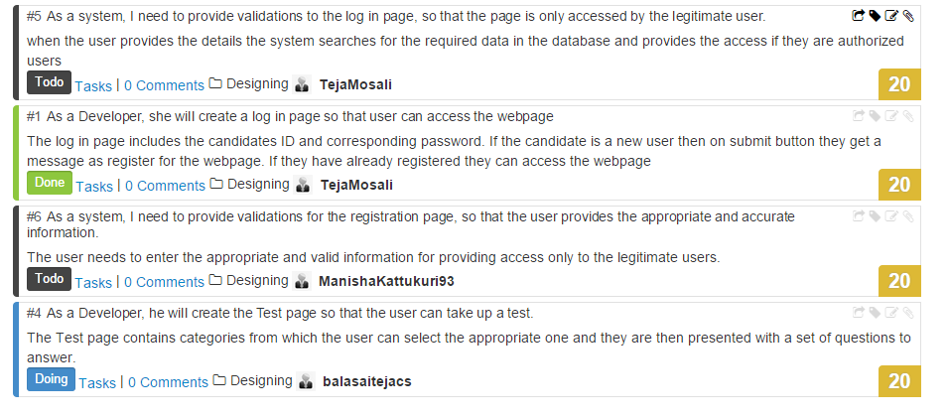

1. **Service Description:**

Visual studio .NET will let us create applications which holds the power of World Wide Web. ASP.NET web services are easy and simple to understand. It is a programmable application logic accessible via standard web protocols. Simple object access protocol is one of those web protocols which uses standard based technologies such as XML and HTTP for transmission and encryption of application data. ASP.NET is a framework that is usually used to build web applications and for building web services.

ASP.NET web form template helps in creating a web application which is based on ASP.NET web form pages which provides the following functionalities

* A master page
* Navigation which uses menu control
* Cascading Style Sheets
* Ajax scripting using JQuery
* Login security which uses ASP.NET membership

By default this template provides the following features,

* A Packages.config file
* A master page
* A global application class
* A Web.config file
* A folder that contains Cascading Style Sheet files, membership pages and client script files
* A data folder that is granted permission which allows ASP.NET to write to it at runtime and read
* Web pages named about.aspx, default.aspx and contact.aspx

1. **Sequence Diagram:**

* **Admin:**

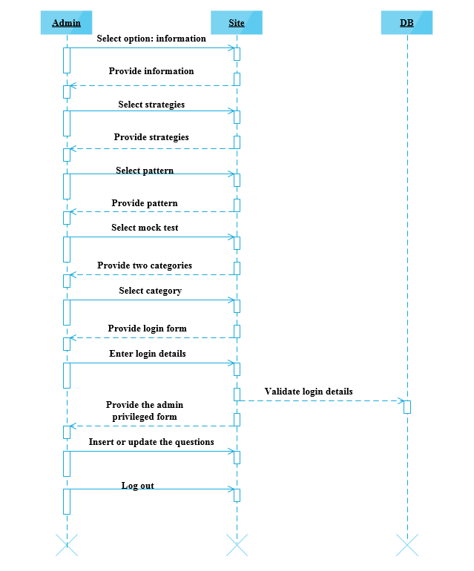

* **Student:**

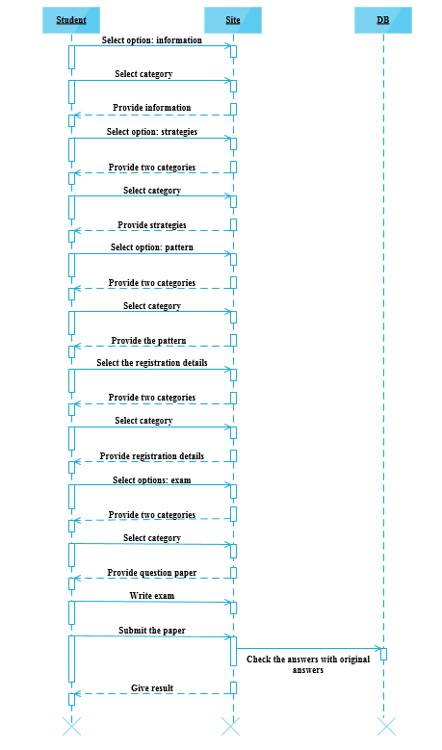

1. **Class Digram:**

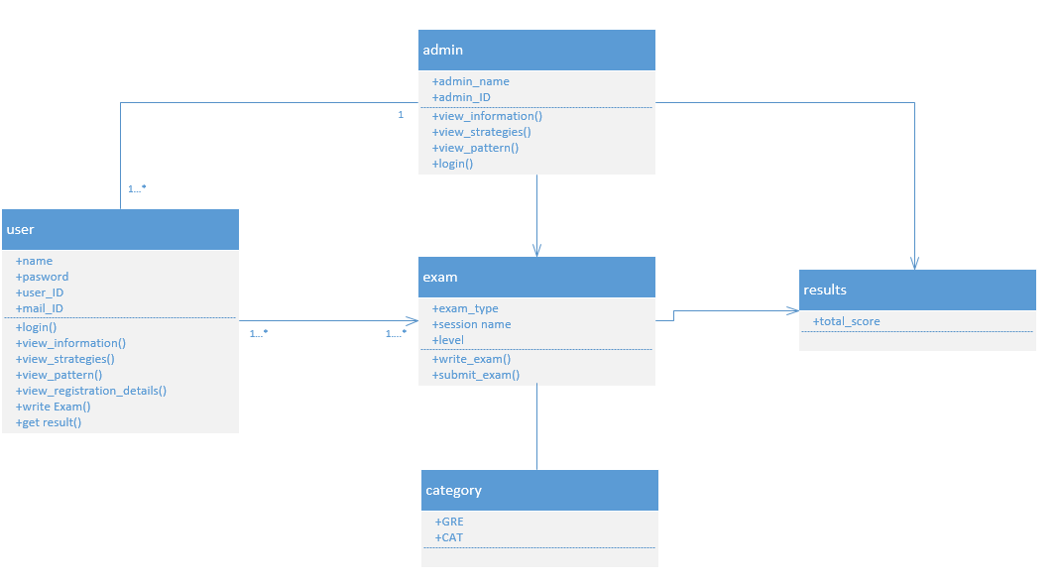

1. **Screenshots and Explanation:**
2. **Master Page:**

This page generally acts as background for all the pages in the application. The styling for this page is provide through the Cascaded Style Sheets.

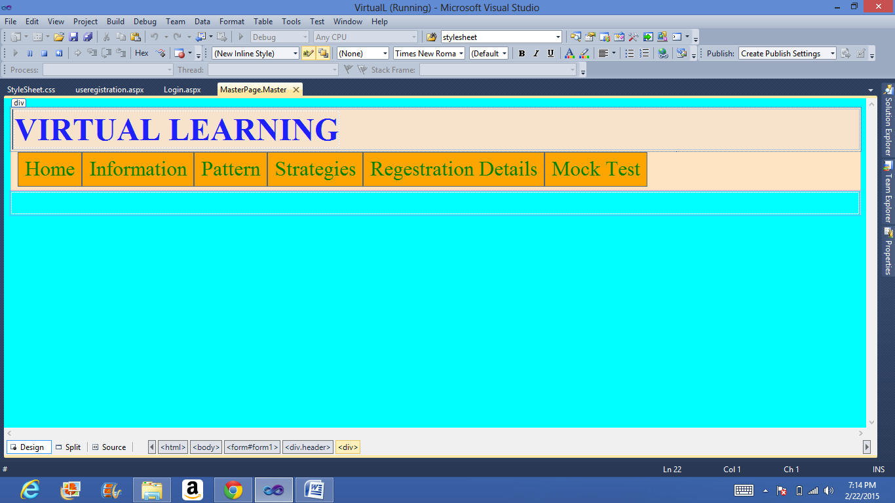

1. **Login Page:**

This is the login page for the application. In this user must give their username and password in order to login and gain access to go further in the application. Upon clicking “Login” button, if the username and password are correct then the user is forwarded to the next page or else user cannot go further and he need to again enter the details.

This login page also contain a link which upon clicking directs the user to a registration page if the user is not registered yet.

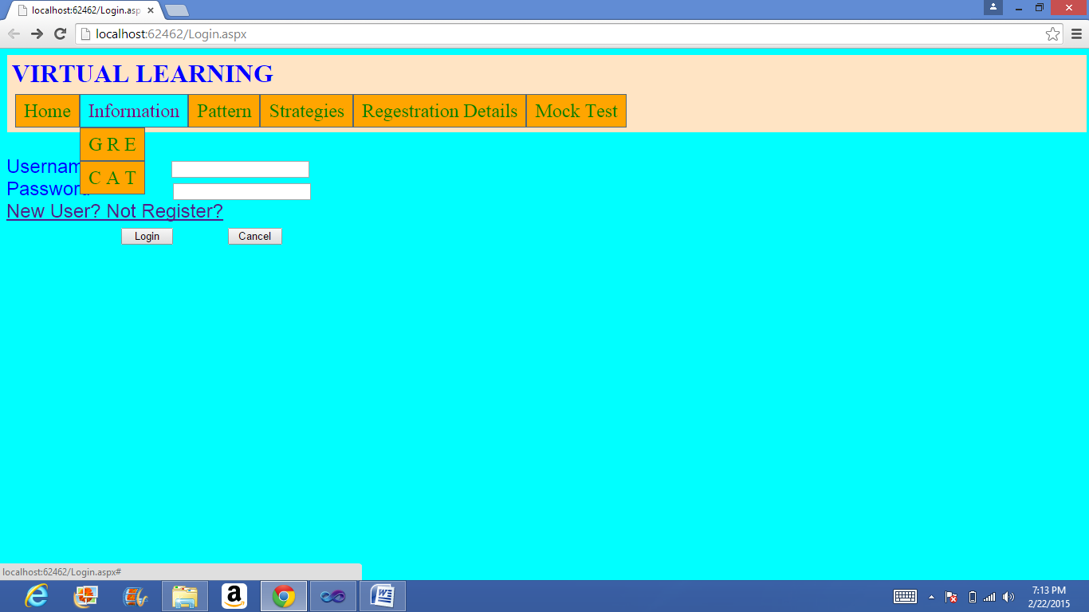

1. **Registration Page:**

This is the registration page for the application. If the user is new to this application then they need to register themselves to the application in order gain access to the application. They need to give their details such as Name, Username, Password and Email ID to register. After this by using their username and password they can sign in to the application.

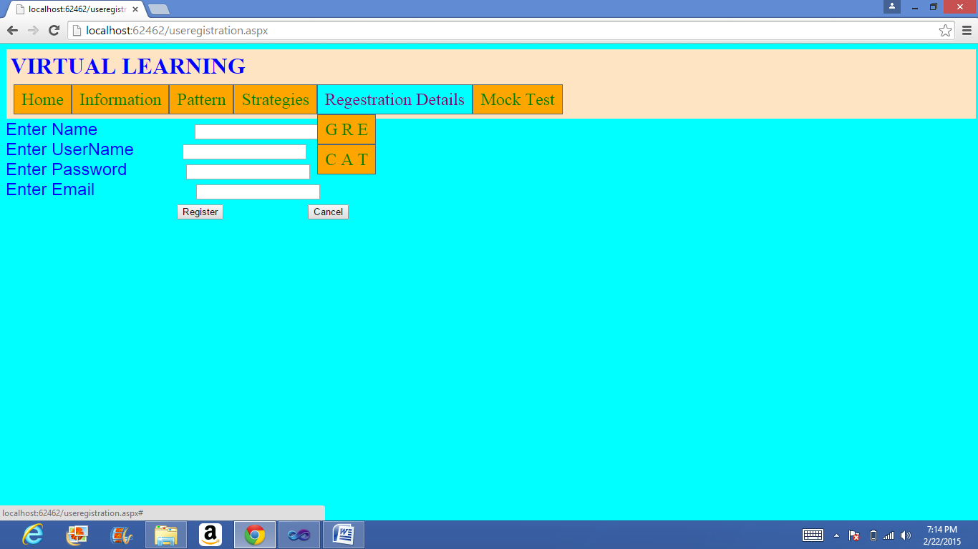

1. **Testing:**
2. **Testcase1**

|  |  |  |
| --- | --- | --- |
| **1.** | **Test case ID** | **Login** |
| **2.** | **Precondition** | * Enter login id * Enter password * Select user type |
| **3.** | **Description** | If login and password match, the user Home Page has to be displayed. |
| **4.** | **Test Steps** | 1. Enter login id 2. Enter Password 3. Select User Type 4. Click “login” button |
| **5.** | **Expected Output** | Home Page of the particular user has to be displayed. |
| **6.** | **Actual Output** | Home Page of the particular user has to be displayed. |
| **7.** | **Status** | **Pass** |
| **8.** | **Remarks** |  |

1. **Testcase2**

|  |  |  |
| --- | --- | --- |
| **1.** | **Test case ID** | **Login failure** |
| **2.** | **Precondition** | * Enter wrong ID. * Enter wrong Password. |
| **3.** | **Description** | If the ID and password mismatch, a error message is displayed |
| **4.** | **Test Steps** | 1. Enter login id 2. Enter Password 3. Select User Type 4. Click “login” button |
| **5.** | **Expected Output** | Alert to be displayed. |
| **6.** | **Actual Output** | Displays a message saying ”Invalid User Id/Password” |
| **7.** | **Status** | **Pass** |
| **8.** | **Remarks** |  |

1. **Deployment:**
2. **Scrum do:**

[**https://www.scrumdo.com/projects/project/virtual-learning1/iteration/122591**](https://www.scrumdo.com/projects/project/virtual-learning1/iteration/122591)

[**https://www.scrumdo.com/projects/project/virtual-learning1/iteration/122591/board**](https://www.scrumdo.com/projects/project/virtual-learning1/iteration/122591/board)

1. **Project URLs:**

[**http://localhost:62462/useregistration.aspx**](http://localhost:62462/useregistration.aspx)

[**http://localhost:62462/Login.aspx**](http://localhost:62462/Login.aspx)